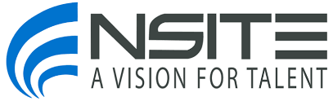

The Getting Hired Playbook (GHP)
Brought to you by NSITE in partnership with AccessAbility Officer

The GHP teaches disabled job seekers the most effective tactics and strategies proven to create more interviews and opportunities for getting hired across a blended 12-week program.
The GHP curriculum, accessible to screen reader users and individuals with other disabilities, presents theoretical concepts for using LinkedIn, step-by-step tactics for using the platform, and is augmented by live hands-on workshops each step of the way.

Program Structure:
100% virtual program combines cohort learning with guided self-paced instruction across 12 weeks with eight live interactive sessions and workshops.

Participant Learning & Program Outcomes:
- Customize your LinkedIn profile and digital business card;
- Develop a strategic and tactical plan for achieving career goals;
- Grow a strong and strategic network for getting hired;
- Develop a presence that shows your thought leadership and market yourself to recruiters; and
- Get more interviews.

Program Start Date: February 05, 2024
Program End Date: April 27, 2024
Program Tuition: $2,750
*Note: GHP tuition is increasing by $825 in the Summer of 2024.
- If you have an open case with a State Vocational Rehabilitation Agency, we can assist you in requesting tuition funding for this program through your VR Counselor.
- If you are an employee of an NIB associated Nonprofit Agency, you may qualify for a National Industries for the Blind (NIB) Training and Professional Development grant. NSITE will be able to provide additional guidance to qualified applicants.

