FOR IMMEDIATE RELEASE
NSITE Reveals Survey Findings Highlighting the Need for Greater Inclusivity in the Workplace
[Washington, DC] – [September 25, 2023] – As National Disability Employment Awareness Month (NDEAM) approaches this October, NSITE, a prominent national not-for-profit organization dedicated to advancing the careers of blind and low-vision individuals, sheds light on the state of diversity, equity, inclusion, and accessibility (DEIA) initiatives in the workplace. The organization recently conducted a comprehensive survey that uncovers vital insights into the perceptions of employees regarding their companies' commitment to individuals with disabilities.
The findings from the survey underscore the urgent need for companies to enhance their efforts in recruiting workers who are blind or low-vision or have other disabilities, seen or unseen, and creating a more inclusive workplace. Among the key findings:
1. Recruitment Awareness: Shockingly, 63 percent of respondents indicated that they either did not believe or were unsure if their company actively recruited disabled candidates.
2. DEIA Training: Similarly, 59 percent of respondents reported not knowing or being uncertain about whether their workplace provided specialized sensitivity training or educational programs concerning disabled employees.
These statistics reveal that essential components of DEIA initiatives are often overlooked in the corporate world.
NSITE's Executive Director, Jonathan Lucus, MPA, EML, noted that these findings, while disappointing, are not entirely surprising. Lucus emphasized, "Unfortunately, we still see resistance to hiring individuals with disabilities like blindness or low-vision, as many decision-makers mistakenly believe that integrating them into the workforce is expensive and time-consuming. However, that is simply not the case."
Lucus further emphasized that accessibility for all is a fundamental principle of NSITE's mission. He stated, "We must break down traditional barriers and shift the corporate mindset from 'not possible' to 'yes, of course' when it comes to hiring these individuals."
Assistive Technology Makes the Workplace More Equitable
One of the challenges NSITE faces is altering perceptions about the capabilities of blind or low-vision employees. Many sighted individuals are unaware of the technology available that enables individuals with vision loss to access information and utilize standard office programs.
Indeed, almost 40 percent of survey respondents expressed disbelief that blind or visually-impaired individuals could work in IT roles, a notion contradicted by NSITE's partnership program with the internationally-recognized CISCO IT Network Academy training program.
In addition to training and upskilling technology specialists, NSITE offers an array of programs, including HR talent sourcing, Contract Management Support, Customer-Centered Communications, basic office tech skills, and an Entrepreneurial Initiative program developed with materials from The Wharton Business School online learning program.
Since 2021, NSITE's job placement program has successfully helped nearly 90 job candidates secure positions aligned with their career goals.
Connecting Employers with Diverse Talent
NSITE also plays a crucial role in supporting businesses committed to genuine diversity and accessibility in the workplace. The organization collaborates with companies hiring blind and low-vision employees to ensure seamless integration into their teams. Furthermore, NSITE offers a "BEI" training program that educates employers and employees about the realities and dispels myths associated with working alongside blind and low-vision individuals.
Jonathan Lucus expressed his hope that next year's survey will reveal better-informed employees regarding their companies' efforts to recruit and retain talent from more diverse backgrounds and experiences.
About NSITE: NSITE provides a continuum of employment services that connect employers with talented, dedicated people who are blind or low-vision, including veterans. NSITE is committed to facilitating smooth and seamless employee-employer matches through talent development, corporate diversity awareness training, and job placement services via the proprietary NSITE CONNECT job board. NSITE is the go-to consultancy for talent and corporate leadership, significantly reducing the unemployment rate for the blind and low-vision community. For more information, please visit NSITE's Website.
About the Survey: In July 2023, NSITE conducted a general consumer survey in partnership with SurveyMonkey, garnering responses from a representative US sample of 535 individuals.
About SurveyMonkey: SurveyMonkey is a global leader in online surveys and forms, empowering people with insights to make informed decisions rapidly and confidently. The platform connects millions of users worldwide with real-time AI-powered insights, driving meaningful decisions.

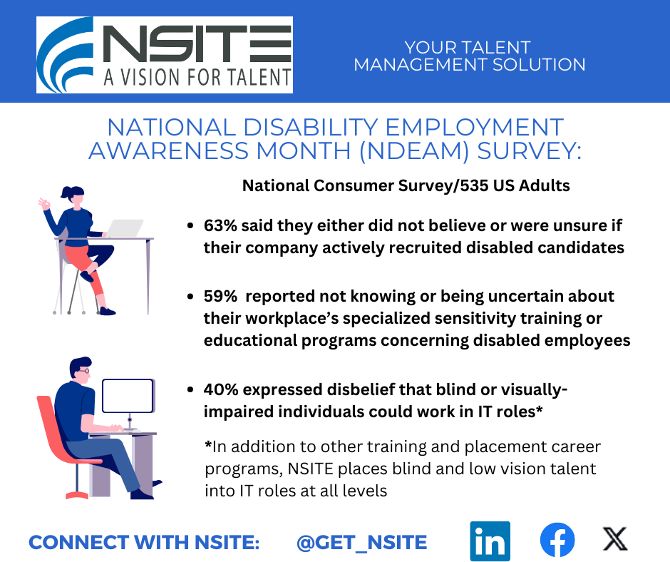

Survey Visual with NSITE logo and slogan “A Vision for Talent” and “Your Talent Management Solution” with illustration of two figures at computer desk,s and the results of the NSITE NDEAM survey with links to NSITE’s @GET_NSITE social media platforms.

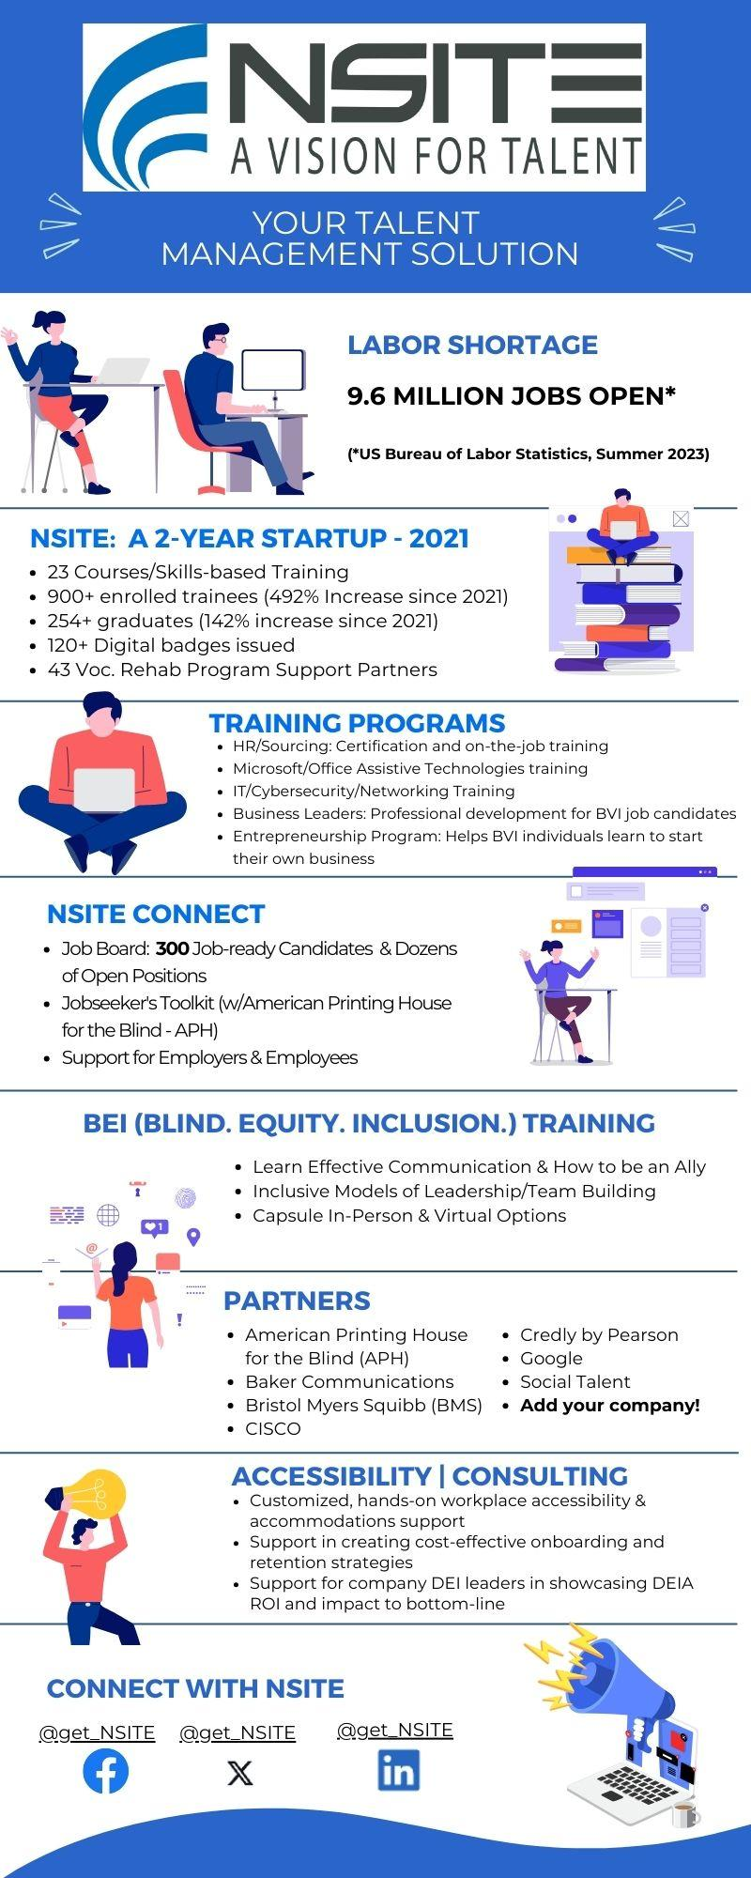

Infographic Caption/Alt Text: 7-part infographic uses line illustrations and facts about NSITE programs and services along with statistics about courses and program graduates. Services are bulleted under categories: Training, NSITE Connect, BEI, Partners and Accessibility/Consulting with links to NSITE’s social platforms.

